**Student Name:**

Balbin, Chrissha Mae E.

**Application Name:**

DigiSong: Platinum Songbook Integrated with Firebase and Video Player/Chewie

**• Rationale**

Singing is a passion deeply ingrained in Filipino culture, with karaoke being an integral part of everyday life. Filipinos take pride in their singing abilities and enjoy showcasing their talents during celebrations and gatherings. However, traditional hardbound songbooks can be cumbersome to use and often lack updates. To address this issue, the DigiSong is designed to provide a faster, more convenient, and updated song browsing experience for karaoke enthusiasts.

This application will provide faster and convenient browsing of songs. Just key-in the title/artist and the user will get the search results in an instant. This application will also filter the genres, new songs and keeps track of the user’s favorite songs. In addition to providing lyrics, DigiSong allows users to play accompanying music videos while singing. This immersive feature replicates the karaoke experience by providing visual cues and enhancing the overall performance.

**• Features**

**Search Title**

Search features are one of the vital elements of a system. The user can find a song by using the dropdown and choose ‘title’ then type at the search bar. It will filter the letters that the user has entered.

**Search Artist**

The application has dedicated search features for a specific artist. The user can find the artist’s songs by using the dropdown and choose ‘artist’ at the upper left of the application.

**Alphabetical Order**

The Digital songbook shall be able sort the song lists into A-Z alphabetical order to help the user navigate through the song lists without any confusion and problem.

**Can filter By Genre**

The Platinum Digital Songbook also provides the user with general organizational patterns that help the user to navigate the organized Songbook in categorized data or lists. Filtering genres can make the user browse songs faster than ever.

**Favorites**

The system shall be able to keep track of the user’s favorite songs using the heart button indicating it is a favorite song.

**On Display Lyrics**

The DigiSong has song lyrics that can be accessed when the user clicks on the ListTile of a song. It also has a zoom-in and zoom-out capability, specifically designed for users with eye problems, such as near and farsighted users. This is a more convenient way for karaoke singers to read or access the lyrics of their chosen songs, as they can hold it in their hands, rather than having to look at a TV screen from a distance.

**• Target Users**

The App Developers are dedicated to provide a Digital Songbook for Filipinos who love singing or even those who are not good at music can still enjoy their karaoke time, using the application compatible with their Platinum Karaoke machine. Navigating songs through a traditional songbook is time consuming and can lead to frustration. The developer team is committed to delivering a better Digital Songbook to its target users; innovating the traditional songbook to a digital songbook will make life easier and better.

**• Importance and Novelty of Application**

The traditional hardbound songbook needs more patience to find a song in a songbook; in addition, singing in gatherings take place and lasts until nighttime, considering the light of the place might be dark it would lead to unreadability for the users who uses the traditional songbook. The majority of target users of the Digital songbook are the middle age group and baby boomers, who are considered to have poor eyesight in a low light place.

Digital Songbook is a great step adopting technological advancement and innovation nowadays, it can help the users navigate through the lists of songs. The Digital Songbook will help the users expedite searching. The proposed application will open its door to businesses, to find opportunities and create and generate more revenues, especially the businesses that rent their Platinum Karaoke machine to provide its users a better experience.

**Screen Shots (User Side)**

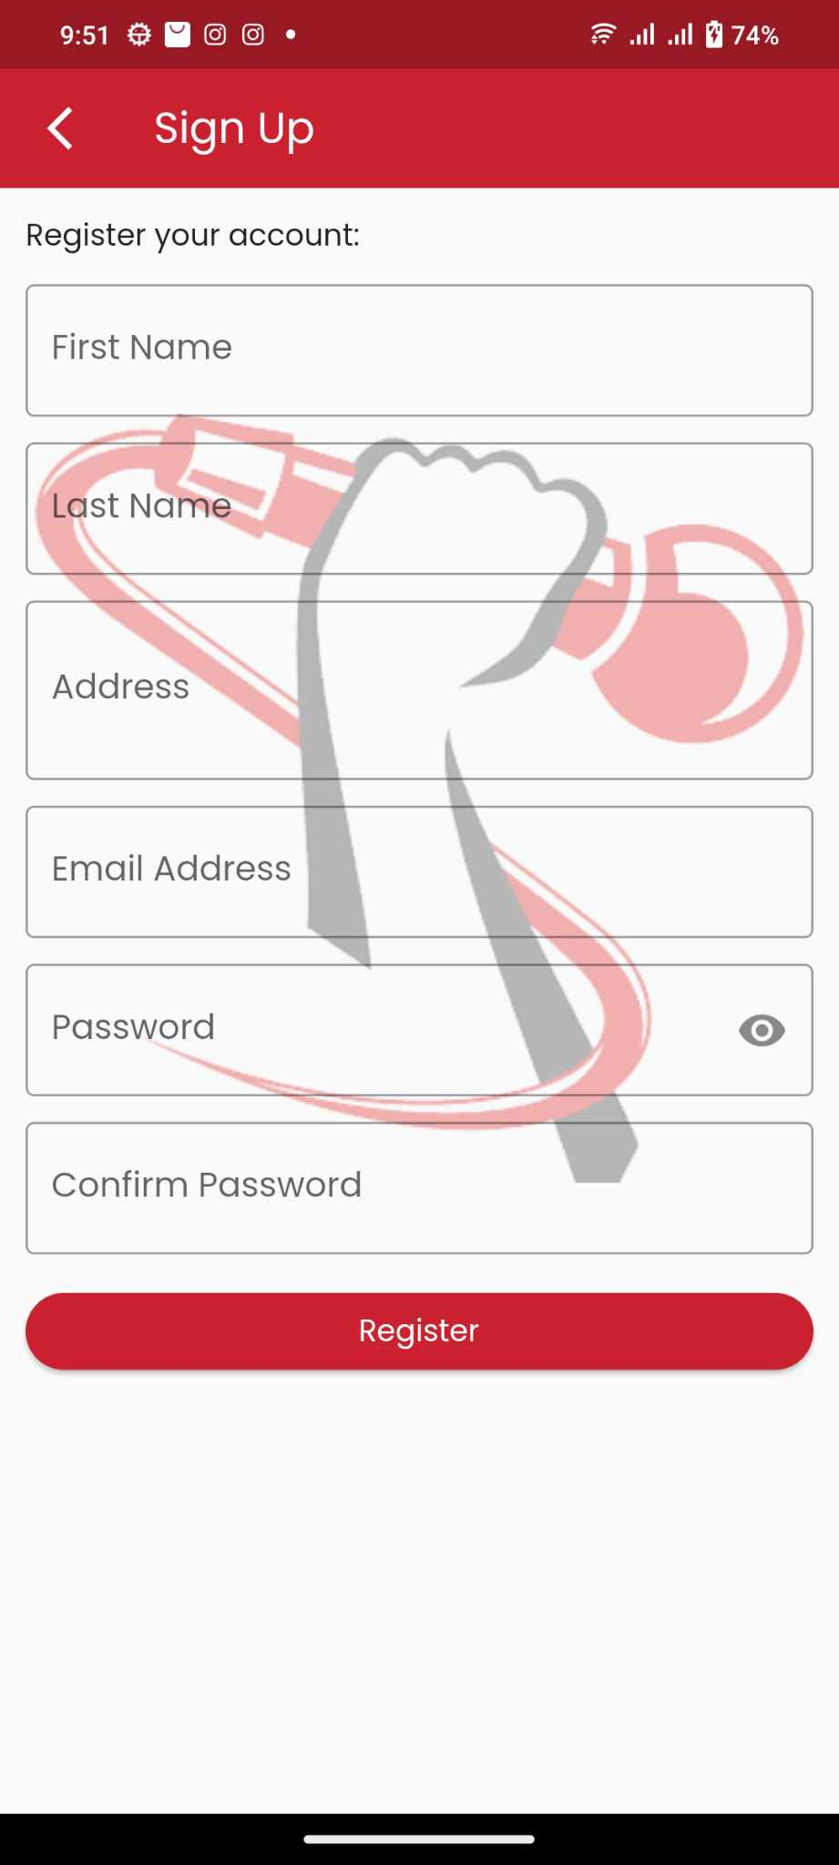

**(Admin Side)**



